ASSIGNMENT 04

<https://wokwi.com/projects/348464798756766290>

**Python code:**

**#define ECHO_PIN2**

**#define TRIG_PIN3**

**#define organization = "pb6xw8"**

**#define deviceType = "abcd"**

**#define deviceId = "12"**

**#define authMethod = "token"**

**#define authToken = "12345678"**

**void setup(){**

**Serial.begin(9600);**

**pinMode(TRIG_PIN,OUTPUT);**

**pinMode(ECHO_PIN,INPUT);**

**}**

**float readDistanceCM(){**

**digitalWrite(TRIG_PIN,LOW);**

**delayMicroseconds(2);**

**digitalWrite(TRIG_PIN,HIGH);**

**delayMicroseconds(10);**

**digitalWrite(TRIG_PIN,LOW);**

**int duration=pulseIn(ECHO_PIN,HIGH);**

**return duration*0.034/2;**

**}**

**void loop(){**

**float distance=readDistanceCM();**

**if(distance<=100)**

**{**

**Serial.println("person detected");**

**}**

**else{**

**Serial.print("Measured distance:");**

**Serial.println(readDistanceCM());**

**}**

**delay(1000);**

**}**

**Simulation:**

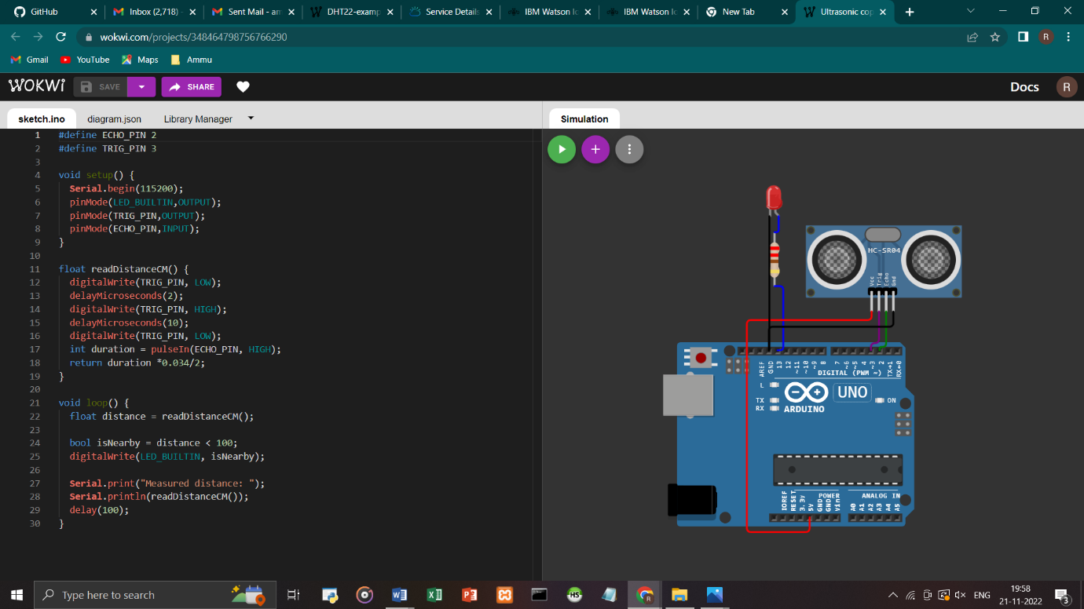

**IBM WATSON CLOUD:**

